**Practical-4**

**AIM: E-R Modeling from the Problem Statements.**

**Introduction:**

Developing databases is a very important task to develop a system. Before going to form exact database tables and establishing relationships between them, we conceptually or logically can model our database using ER diagrams.

In this experiment we will learn how to find the entities, its attributes and how the relationships between the entities can be established for a system.

**Theory: -**

**Entity Relationship Model**

Entity-Relationship model is used to represent a logical design of a database to be created. In the ER model, real world objects (or concepts) are abstracted as entities, and different possible associations among them are modeled as relationships.

For example, student and school -- they are two entities. Students study in school. So, these two entities are associated with a relationship "Studies in".

As another example, consider a system where some job runs every night, which updates the database. Here, job and database could be two entities. They are associated with the relationship "Updates".

## Entity Set and Relationship Set

An entity set is a collection of all similar entities. For example, "Student" is an entity set that abstracts all students. Ram, John are specific entities belonging to this set. Similarly, a "Relationship" set is a set of similar relationships.

## Attributes of Entity

Attributes are the characteristics describing any entity belonging to an entity set. Any entity in a set can be described by zero or more attributes.

For example, any student has got a name, age, an address. At any given time a student can study only at one school. In the school he would have a roll number, and of course a grade in which he studies. These data are the attributes of the entity set Student.

## Keys

One or more attribute(s) of an entity set can be used to define the following keys:

* **Super key:** One or more attributes, which when taken together, helps to uniquely identify an entity in an entity set. For example, a school can have any number of students. However, if we know the grade and roll number, then we can uniquely identify a student in that school.
* **Candidate key:** It is a minimal subset of a super key. In other words, a super key might contain extraneous attributes, which do not help in identifying an object uniquely. When such attributes are removed, the key formed is called a candidate key.
* **Primary key:** A database might have more than one candidate key. Any candidate key chosen for a particular implementation of the database is called a primary key.
* **Prime attribute:** Any attribute taking part in a super key

## Weak Entity

An entity set is said to be weak if it is dependent upon another entity set. A weak entity can't be uniquely identified only by it's attributes. In other words, it doesn't have a super key.

For example, consider a company that allows employees to have travel allowance for their immediate family. So, here we have two entity sets: employee and family, related by "Can claim for". However, family doesn't have a super key. Existence of a family is entirely dependent on the concerned employee. So, it is meaningful only with reference to employee.

## 

## Entity Generalization and Specialization

Once we have identified the entity sets, we might find some similarities among them. For example, multiple person interacts with a banking system. Most of them are customers, and rest employees or other service providers. Here, customers, employees are persons, but with certain specializations. Or in other way, person is the generalized form of customer and employee entity sets.

ER model uses the "ISA" hierarchy to depict specialization (and thus, generalization).

## Mapping Cardinalities

One of the main tasks of ER modeling is to associate different entity sets. Let's consider two entity sets E1 and E2 associated by a relationship set R. Based on the number of entities in E1 and E2 are associated with, we can have the following four type of mappings:

* **One to one:** An entity in E1 is related to at most a single entity in E2, and vice versa
* **One to many:** An entity in E1 could be related to zero or more entities in E2. Any entity in E2 could be related to at most a single entity in E1.
* **Many to one:** Zero or more number of entities in E1 could be associated to a single entity in E2. However, an entity in E2 could be related to at most one entity in E1.
* **Many to many:** Any number of entities could be related to any number of entities in E2, including zero, and vice versa.

## ER Diagram

From a given problem statement we identify the possible entity sets, their attributes, and relationships among different entity sets. Once we have these information, we represent them pictorially, called an entity-relationship (ER) diagram.

## Graphical Notations for ER Diagram

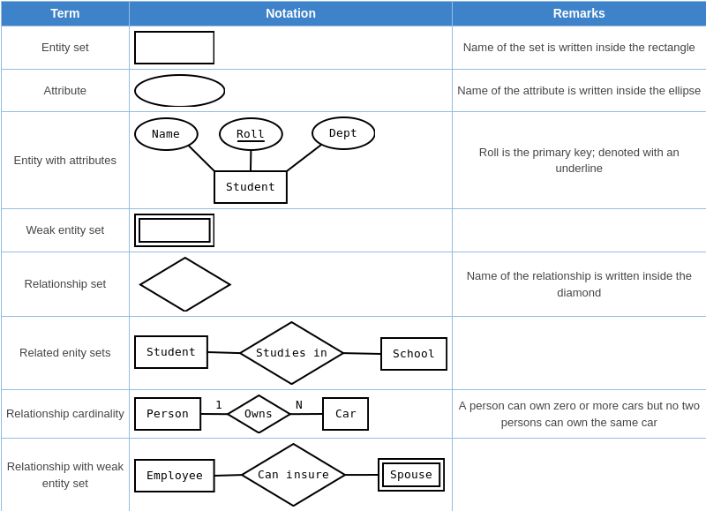

## Importance of ER modeling

Figure - 01 shows the different steps involved in implementation of a (relational) database.



Given a problem statement, the first step is to identify the entities, attributes and relationships. We represent them using an ER diagram. Using this ER diagram, table structures are created, along with required constraints. Finally, these tables are normalized in order to remove redundancy and maintain data integrity. Thus, to have data stored efficiently, the ER diagram is to be drawn as much detailed and accurate as possible.

**Case Study:**

## #1 : A Library Information System for SE VLabs Institute

The SE VLabs Institute has been recently setup to provide state-of-the-art research facilities in the field of Software Engineering. Apart from research scholars (students) and professors, it also includes quite a large number of employees who work on different projects undertaken by the institution.

As the size and capacity of the institute is increasing with the time, it has been proposed to develop a Library Information System (LIS) for the benefit of students and employees of the institute. LIS will enable the members to borrow a book (or return it) with ease while sitting at his desk/chamber. The system also enables a member to extend the date of his borrowing if no other booking for that particular book has been made. For the library staff, this system aids them to easily handle day-to-day book transactions. The librarian, who has administrative privileges and complete control over the system, can enter a new record into the system when a new book has been purchased, or remove a record in case any book is taken off the shelf. Any non-member is free to use this system to browse/search books online. However, issuing or returning books is restricted to valid users (members) of LIS only.

The final deliverable would a web application (using the recent HTML 5), which should run only within the institute LAN. Although this reduces security risk of the software to a large extent, care should be taken no confidential information (eg., passwords) is stored in plain text.

A robust database backend is essential for a high-quality information system. Database schema should be efficiently modeled, refined, and normalized. In this section we would develop a simple ER model for the Library Information System.

The first step towards ER modeling is to identify the set of relevant entities from the given problem statement. The two primary, and obvious, entity sets in this context are "Member" and "Book". The entity set "Member" represents all students, professors, or employees who have registered themselves with the LIS. While registering with the LIS one has to furnish a lot of personal and professional information. This typically includes name (well, that is trivial), employee ID (roll # for students), email address, phone #, age, date of joining in this institute. The system may store some not-so-important information as well like, blood group, marital status, and so on. All these pieces of information that an user has to provide are sufficient to describe a particular member. These characteristics are the attributes of the entities belonging to the entity set "Member".

It is essential for an entity to have one or more attributes that help us to distinguish it from another entity. 'Name' can't help that -- two persons could have exactly the same name. However, ('Name', 'Phone #') combination seems to be okay. No two persons can have the same phone number. 'Employee ID', 'Email address' are other potential candidates. Here, 'Employee ID', 'Email address' and ('Name', 'Phone #') are super keys. We choose 'Employee ID' to uniquely identify an user in our implementation. So, 'Employee ID' becomes our primary key (PK) for the "Member" entity set. Figure 1 represents this set along with it's attributes and the primary key.

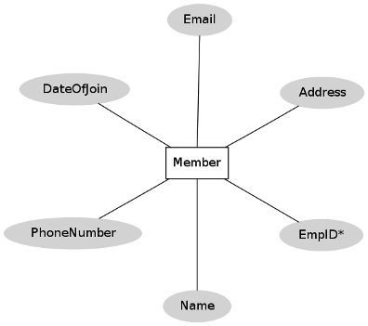

Figure 1: "Member" entity set

Let us now focus on the "Book" entity set. Typical attributes of a book are it's title, name of author(s), publisher, date of publication, edition, language, ISBN-10, ISBN-13, price (of course!), date of purchase. The set of listed attributes for a book doesn't give a straight forward choice of primary key. For instance, several books could have the same title. Again, ISBN numbers for a book are specific to it's edition -- it can't distinguish between two books of the same edition. One might be tempted to use a combination of ('Title', 'Authors') as a primary key. This has some shortcomings. It is advisable not to use texts as a PK. Moreover, the number of authors that a book could have is not fixed, although it is a small, finite number. The rules of normalization (not covered here) would dictate to have a separate field for each author like 'Author1', 'Author2', and so on. Therefore, we assign an extra attribute, 'ID', to each book as it's PK. Different databases available in the market provide mechanisms to generate such an unique ID, and automatically increment it whenever a new new entity is added. In fact, we could assign such an ID to the "Member" entity set as well. However, because of availability of the unique 'Employee ID' field, we skipped that. A graphical representation of the "Book" entity set is shown in figure 2.

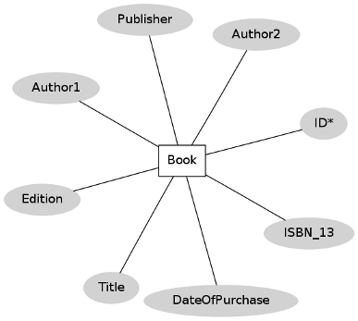

Figure 2: "Book" entity set

One point to note here is that a book is likely to have multiple copies in the library. Therefore, one might wish to have a '# of copies' attribute for the "Book" entity set. However, that won't allow us to differentiate among the different copies of book bearing same title by same author(s), edition, and publisher. The approach that we have taken is to uniquely identify each book even though they are copies of the same title.

To buy any new book an order is to be placed to the distributor. This task is done by the librarian. Therefore, "Librarian" and "Distributor" are two other entities playing roles in this system.

Having identified the key entities, we could now relate them with each other. Let us consider the entity sets "Member" and "Book". A member can issue books. In fact, he can issue multiple books up to a finite number say, N. A particular book, however, could be issued by a single member only. Therefore, we have a one-to-many mapping from "Member" to "Book" entity sets.

This relationship between "Member" and "Book" entity sets is pictorially depicted in figure 3.

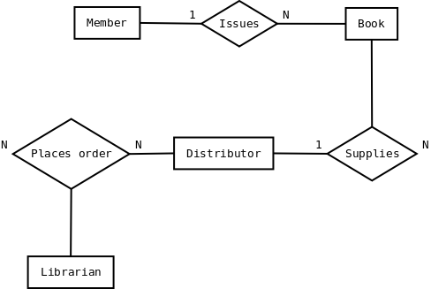

Figure 3: Relationships among different entity sets

Figure 3 also shows that the librarian can "place order" for books to the distributor. This is a many-to-many mapping since a librarian can purchase books from multiple distributors. Also, if the institute has more than one librarians (or any other staff having such authority), then each of them could place order to the same distributor. An order is termed as complete when distributor supplies the book(s) and invoice.

The design in figure 3 has a flaw. Librarian himself could be a member of the LIS. However, he is a "special" kind of member since he can place order for books. Our ER diagram doesn't reflect this scenario. Such special roles of an entity set could be represented using "ISA" relationship, which is not discussed here.

Any kind of designing couldn't be possibly done at one go. Therefore, the baseline ER model so prepared should be revised by considering the business model yet again to ensure that all necessary information could be captured. Once this has been finalized, the next logical step would be to create table structures for each identified entity set (and relationships in some cases) and normalize the relations.

**Exercise-4**

**Draw E-R Diagrams for the Following:**

**Example-1**

**Draw E-R diagram: student Management system**

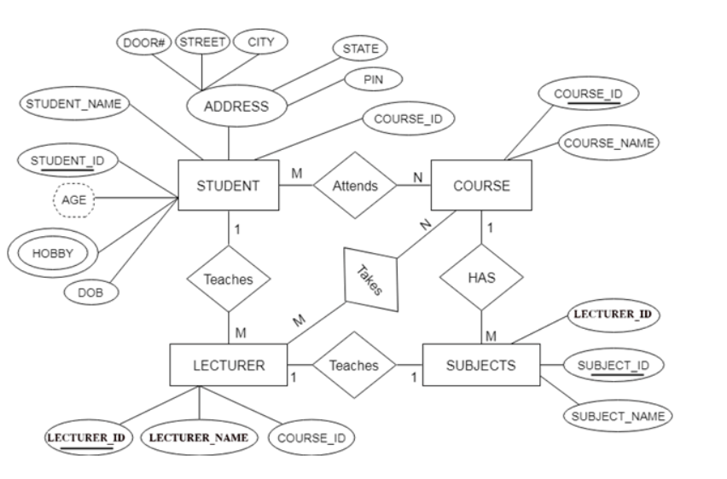

**Example-2**

**Draw E-R Diagram: DE Project (Restaurant Management System)**

